Project Development – Delivery of Sprint-2

|  |  |
| --- | --- |
| Team ID | PNT2022TMID47580 |
| Project Name | Smart Solutions for Railways |

**Sprint-2 :**

* In sprint 2 Our developed a node red application that describes the workflow of our smart solutions for railways project
* This application is useful for to understand how the data is given by the user and how the data flow through the database and then it converted into qrcode through the user details can be retried by the TTR.
* The python code was developed to scan the qrcode and retrieve the user information from the Cloudant database.

**Node-red Application Flow:**

### 

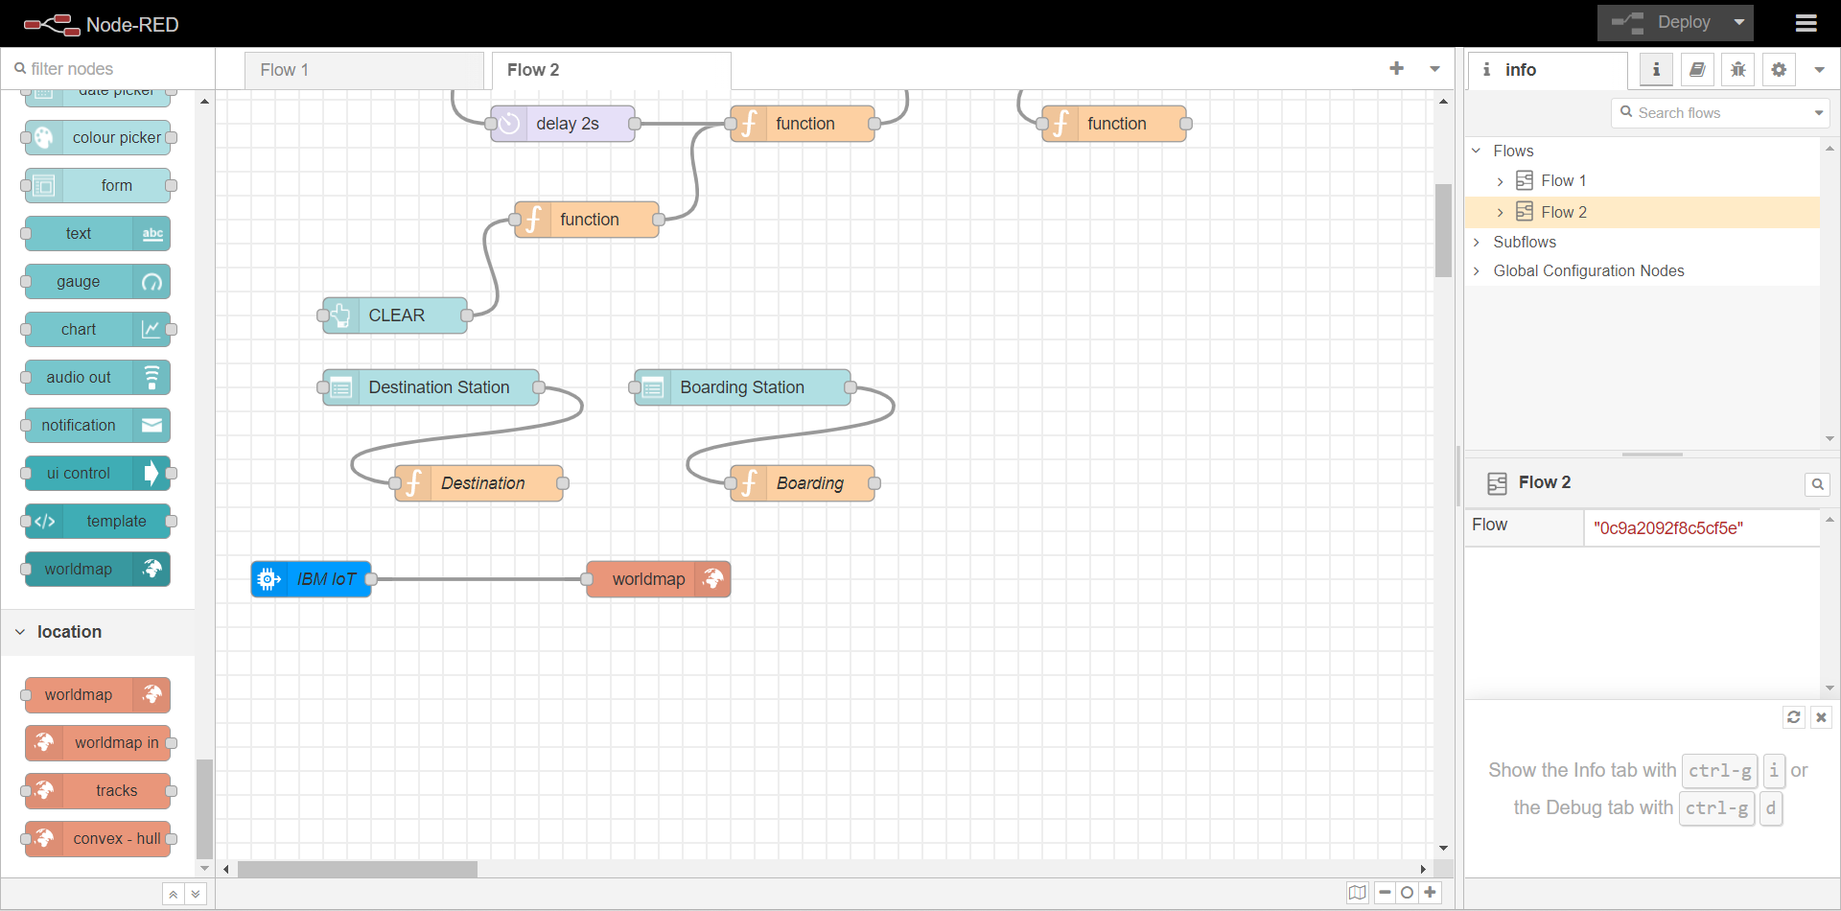

**Output:**

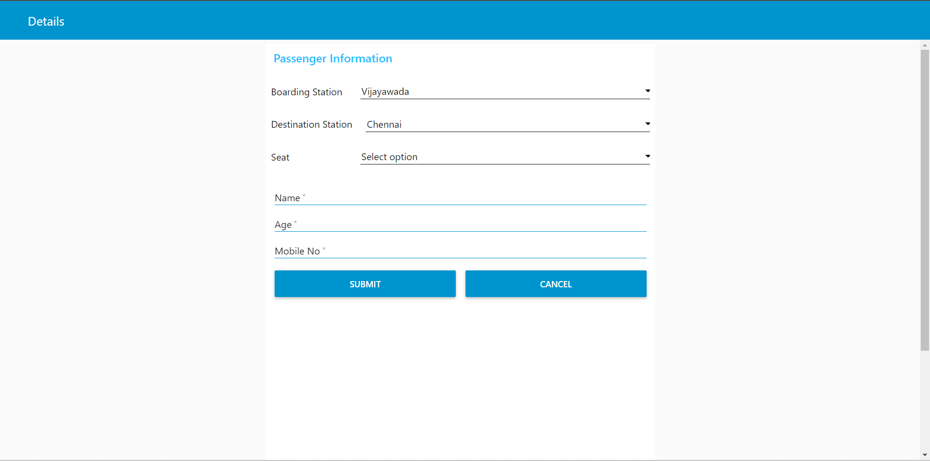

**Python Code:**

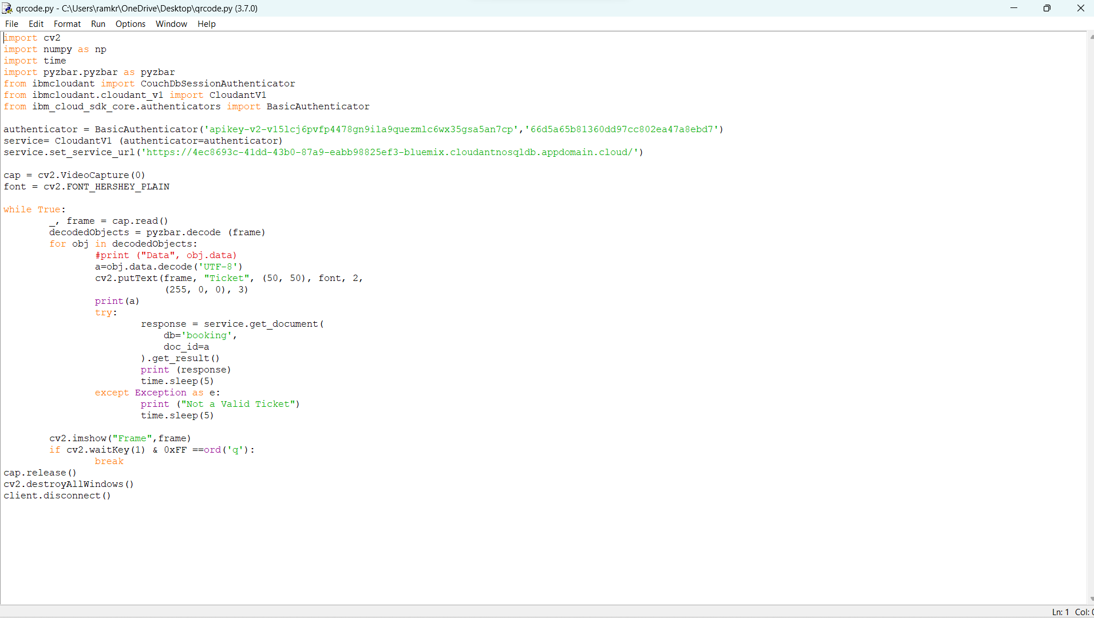

**Output :**

